Standard Operating Procedure

|  |  |
| --- | --- |
| [Cisco incentive program] | |
|  | |
|  | |
| SOP Number | XXXX |
| Customer | NTT Germany |
| Organization/Area | DE01 |

Table of Contents

1 Document Control 3

1.1 Document Location 3

1.2 Document Creation 3

1.3 Revision History 3

2 Acronyms, Process Legends, and Definitions 4

3 Overview 5

3.1 Objective of the document 5

3.2 Value stream impacted and supporting systems 5

3.2.1 Value Stream 5

3.2.2 Supporting System 5

3.2.3 Technical Support 5

3.3 Assumptions and exclusions 6

3.4 Guiding principle 6

4 Business Process 7

4.1 Value stream and process group (Level 2) 7

4.2 Business process (Level 3) 7

4.3 Business process activity map 7

4.4 Business process task 7

5 Exceptions 8

6 Compliance documents to business process 9

7 Other key documents 10

8 Sign Off 11

# Document Control

## Document Location

[Arial 10 – Share path / link of the SOP]

## Document Creation

|  |  |  |
| --- | --- | --- |
| Creation Date: | Genpact Approval By: | Customer Approval By: |
| 05/2022 | Katarzyna Krzywon | Frank Simon |

## Revision History

|  |  |  |  |  |  |
| --- | --- | --- | --- | --- | --- |
| Revision Date: | Version Number: | Change Reason: | Pages Changed (pg. no.) | Genpact Approval By: | Customer Approval By: |
| 09/2023 | 01 | New template being used & new files being needed for the posting | 6-25 | Daniel Stan | Moritz Emig |
|  |  |  |  |  |  |
|  |  |  |  |  |  |
|  |  |  |  |  |  |

# Acronyms, Process Legends, and Definitions

[Arial 10 – Add link to the library]

# Overview

## Objective of the Document

## Value Stream Impacted and Supporting Systems

### Value Stream

|  |  |
| --- | --- |
| Value Stream (L1) | Definition (L1) |
|  |  |
|  |  |

### Supporting System

[Arial 10 –Please provide an overview of the system used in the process, e.g. the ERP systems, such as SAP and other applications]

### Technical Support

|  |  |
| --- | --- |
| System Name | Usage |
|  |  |
|  |  |
|  |  |
|  |  |

## Assumptions and Exclusions

[Arial 10 – Please provide detailed description of all exceptions to the standard process captured. Please link each exception with the process step and maintain an exception tracker, only the path / link of the tracker should be added.]

## Guiding Principle

[Arial 10 – Refer to notation standard BPMN 2.0]

# Business Process

## Value Stream and Process Group (Level 2)

[Arial 10 – Mention value stream (L1) and aligned process group (L2) along with definition relevant to the SOP.

## Business Process (Level 3)

[Arial 10 – Mention business process (L3), definition and value created (L3)

## Business Process Activity Map

[Arial 10 - E2E including both retain and service provider) @ Activity (level 4) Per entity & scenario Activity, associated role (retain or service provider), system, KPI, SLA, key input and key outputs]

## Business Process Task

Cisco incentive program covers 6 months. The bigger turnover at the end of Cisco program, the greater rebate will be final bonus. The name of the current program is VIP41, started in January 2023.

To join to Cisco incentive program many conditions must be met.

All conditions and rules are to find in VIP Program Rules (see below) Rules will change each VIP-Program. It`s important to read the program rules for each program.

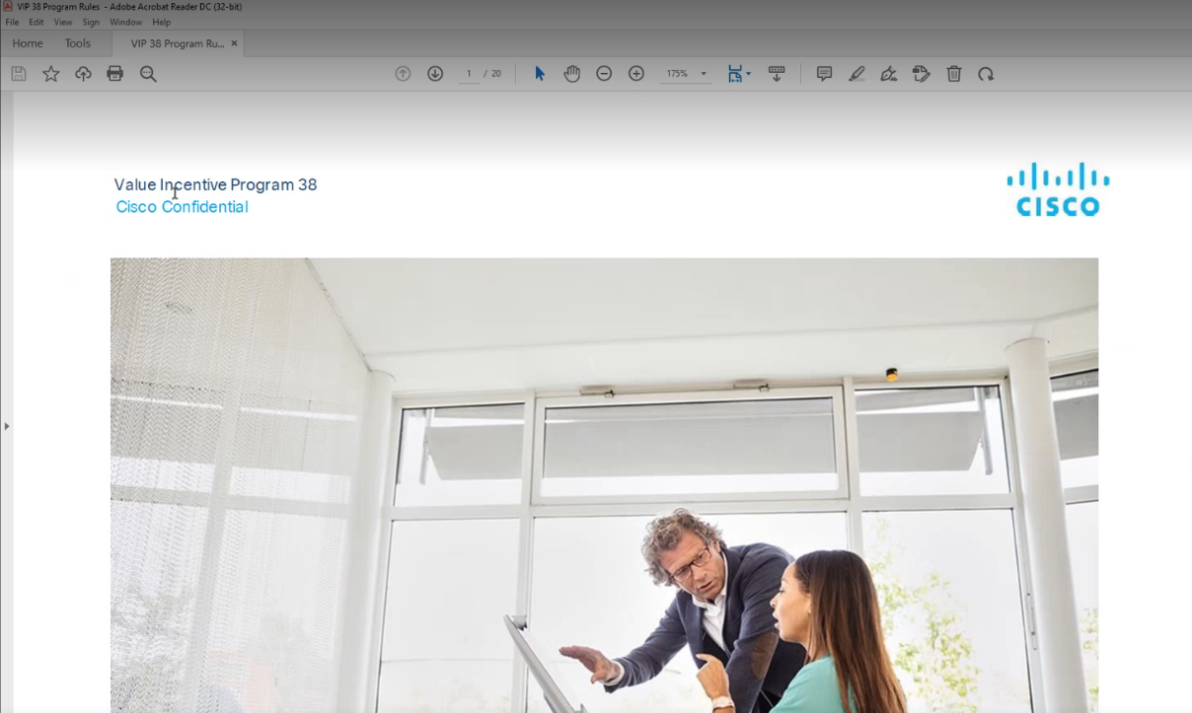

Alliance Management Team:

Doreen Jöchl

Doreen will provide information about the existing certifications we have.

For access to the Cisco Total Program View (TPV)-Tool, you have to register at Cisco.com once.

When you have access go to: <https://cisco-pxp.force.com/pxp/s/>

And login with your NTT Mail

Click on Reporting

Click on VIP

Click on Eligible Bookings

You need to fill in those fields. Currently we also run VIP 40, so you have to Request VIP40 & VIP41 per Mail

Click on Request by mail

Both reports will send to you via mail with a link#

Click on the link eligible architecture bookings

The file will automatically download itself

You will need the marked files to prepare the Cisco eligible file 40/41

To prepare both files you will follow the exact same path. We start with making sure that all the links in the sheet Link are in the same folder with the same name

The next step is to open the last month File and copy the Column F:H and paste it in the new file column A:C

This is important to calculate the next month and to get correct calculation

Click on Data Refresh All and you will see the actual result

On the Sheet Report you will see an overview and the current month result

The sheet Posting doc will automatically generate the posting journal with you will use to book the accruals for this program

This will be done at WD1

You will find the old booking journals in the last month ZDTON folder.

Use them as a template and create the new ones

Go to this Link to post the journals: [General Ledger - Germany - Manual Posting Request - Open_Items_View (sharepoint.com)](https://nttlimited.sharepoint.com/teams/71m9y/DE_GL/Lists/Manual%20Posting%20Request/AllItems.aspx?params=eyJBcHBOYW1lIjoiVGVhbXMtRGVza3RvcCIsIkFwcFZlcnNpb24iOiIyNy8yMjA1MDEwMTAwOSJ9&OR=Teams%2DHL&CT=1675697598550&clickparams=eyJBcHBOYW1lIjoiVGVhbXMtRGVza3RvcCIsIkFwcFZlcnNpb24iOiIyNy8yMzAxMDEwMDkxMyIsIkhhc0ZlZGVyYXRlZFVzZXIiOmZhbHNlfQ%3D%3D)

Posting Reference same as in the journal, Category Tech, Attachments: the journal…

The sheet param is used to edit the rules for this template. If there are new ones you can edit it here

The sheet missing defs shows you if one of the deals from the reporting is missing in the definition. You can then edit in param.

In sheet data you see the raw data which is used in this template

The sheet SAP open itemns is unclear

The account this accrual will be booked is 110390 if we get the bonification from cisco this account will balance it

It is important to check the accounts regular and to talk with the business partner Doreen Jöchl.

# Exceptions

[Arial 10]

# Compliance Documents to Business Process

[Arial 10 – Associated Compliance Documents to Business Process (level 3) example - SOX, Policies (Link to applicable documents]

# Other Key Documents

[Arial 10 - “Service Delivery” i.e. Engagement Model (Link to applicable documents)]

# Sign Off

